Concentrix Waste Management Policy (Version 1.0 _2023)

Document Control

Revision/Approval History
Version number | Effective Date | Summary of changes if any | Author(s) | Reviewer(s) | Approver(s)
Version 1.0 | July 2023 | Initial Documentation | Rashmi Sood/ Beth Pamatmat | Mark Gorman | Philip Cassidy

Document Change Reviewers :
Concentrix VP, Real Estate
Document Change Approvers :
Concentrix EVP, Corporate Strategy, Special Projects & Real Estate

Major changes require approval of the above personnel. Minor changes require approval of any one of the Document Change Reviewers only. Minor changes are those that affect cosmetics and clarifications, but not the overall structure / scope of the process and this policy.

Document Review Plan
This document will be reviewed at least annually, or as necessary to address any new or changed legislation, regulations, or business practices.

Contact Information
For further information or queries on this Policy, contact

- Introduction
All used products that have reached end-of-life or use," require appropriate disposal to limit their harm to the environment. Waste disposal is therefore a systematic action for managing waste from a product’s acquisition to its final disposal. Such actions may include incineration or burning, burial at landfill sites or discharge at sea, lake, or river, and recycling.
Concentrix has adopted the 5R approach to managing the waste produced in our operations. Key to this approach is ensuring that four R-actions are performed first before actual recycling: refusal or avoidance of unnecessary purchases, especially of non-recyclable products; reduction of the purchase of non-recyclable products; reuse of existing products for the same purpose; repurposing or upcycling products for another use; and finally, recycling used products through programmes and partnerships with external vendors and agencies that provide such services.
5 R Approach.
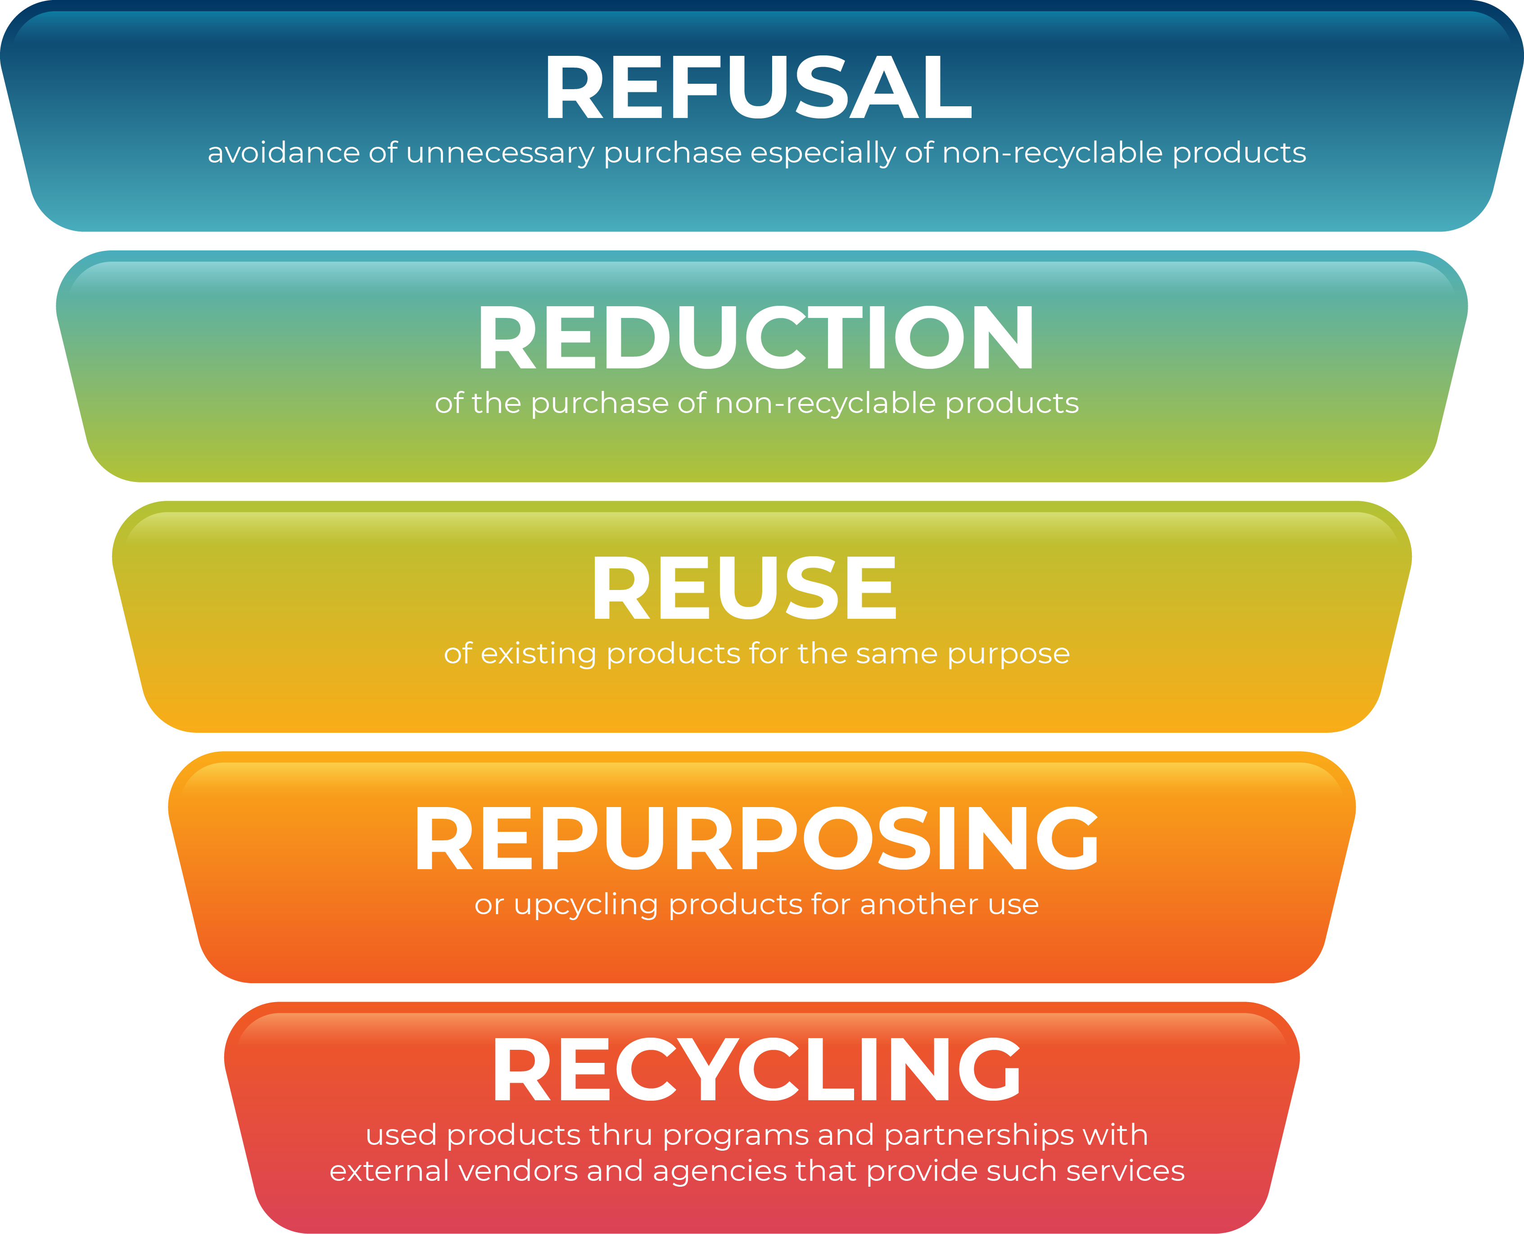

Refuse (avoid): To ‘refuse’ waste in the first place, make smarter purchasing decisions and set expectations and standards early in the process.
Reduce: This involves reducing the use of non-recyclable, wasteful, and harmful products. This will reduce the number of waste materials ending up in landfills and the associated negative environmental impacts. To avoid unnecessary waste, it’s recommended to always use the minimum amount required.
Reuse: One of the world’s greatest environmental challenges is the plastic crisis due to the high rate at which we consume plastic. It is normal consumer behavior to use single-use plastics once and then throw them away. Consider reusing items throughout the workplace instead of buying new ones to reduce waste. Also, replace all the single-use eating utensils with paper plates that are reusable or compostable.
Repurpose (recover): Try repurposing every item that can’t be reduced, reused, or recycled. Many common office products serve more than one purpose, though sometimes it requires creativity. This process is also known as upcycling. Tin cans and mason jars can be used for holding pencils and pens.
Recycle: This is the most environmentally friendly waste disposal method of all the other R’s. With an effective recycling program, most companies have been able to reduce the amount of waste they produce.
- Scope
All Concentrix facilities and operations are covered under the scope of the policy.

- Applicability
This policy is applicable to all facility operations managed by Concentrix.

- Inclusions, Assumptions & Extended responsibilities
The implementation of Concentrix’s waste management policy and processes will be managed through the Real Estate team and covers:
1. Concentrix floors with control over waste management and disposal (typical for Concentrix- owned sites)
a. Concentrix shall be responsible for installing waste segregation facilities.
b. Concentrix shall be responsible for the implementation of waste segregation facilities within the building.
c. Concentrix shall be responsible for implementing recycling mechanisms for plastic, paper, aluminium, and food waste (where possible);
d. Concentrix shall be responsible for selecting the proper waste disposal partner for all residual waste or non-recyclable waste.
e. Concentrix shall be responsible for reporting all waste data in line with environmental disclosure.
- Any infra-modification or construction project undertaken by Concentrix.
- Waste segregation should be implemented across all Concentrix sites. Wherever there is no control or limited control over waste management and disposal by Concentrix, it is assumed that the waste will be managed by the landlord and that Concentrix requirements will be communicated. Further, the landlord will have the responsibility.
    - to share the details of waste generated with Concentrix (as specified at the facility or country level),
    - along with the method adopted for disposal and
    - the details of vendors identified.
    - Concentrix should ensure the above-mentioned points are included in the site or building selection process and should be working directly with respective landlords to incorporate as many of the points mentioned in Section IV(a).

- Construction waste management will be under the oversight of the Concentrix Projects and Construction team. Actual waste management will typically be the responsibility of the general contractor, an external consultant, or an external project manager. The vendor or partner designated will need to provide Concentrix with details on the quantity of waste generated, waste reduction and recycling plans (if any), and diversion plans that are aligned with Concentrix's environmental sustainability targets and policies. (For further details, please refer to the Construction and Demolition Waste Management Process.)

- Concentrix Commitments
In pursuance of our stated Environmental Social and Governance (ESG) commitment to reduce waste to landfills and close the loop on waste by employing the 5R methodology (refuse, reduce, reuse, repurpose, and recycle) and, where necessary, responsibly dispose of waste, we have adopted several key actions towards which we will strive.
Key waste metrics, such as elimination of single-use plastic water bottles and the like, as well as waste impact on overall company emissions, are identified and reviewed annually, and these are supported by a range of actions, improvements, and initiatives through which those targets are to be achieved. These are as follows:
- Concentrix shall identify all waste sources, their type and quantity, and track and report waste generated in Concentrix facilities.
- Concentrix shall ensure that all the identified waste is appropriately segregated as per the below categorization.
  - Biodegradable Waste: Biodegradable materials are those that degrade or break down in a natural manner. Thus, these substances are non-toxic to the environment because they are composed of only natural materials. For instance, fruits, vegetables, flowers, plants, animals, water, paper, and more are examples of biodegradable waste.
  - Non-biodegradable substances are materials that do not degrade easily. As they are synthesized and do not occur naturally. For instance, plastics, chemicals, rubber, paints, and metals all fall into this category.
  - Hazardous: non-biodegradable substances are materials that do not degrade easily. Hazardous waste is waste with properties that make it dangerous or capable of having a harmful effect on humans and the environment. Examples: biomedical waste, batteries, waste oils and lubricants, solvents, etc.
  - Plastic Waste: Plastics are a wide range of synthetic or semi-synthetic materials that use polymers as their main ingredient. All single-use plastics Examples: cling film, blister packaging Plastic-coated paper, composite plastic, bioplastics, polycarbonate, thermoset plastics, or polyvinyl chloride
  - Electronic Waste: E-waste or electronic waste is any electrical or electronic equipment that’s been discarded or has reached its end of life. This includes working and broken items that are thrown away or donated to a charity reseller, their components, consumables, parts, and spares.
  - Construction and demolition waste or debris: waste generated during construction, demolition, or renovation (re-modelling) of any structure or building (residential, office, commercial, etc.) or associated activities for infrastructure provision.

- Concentrix shall ensure that there is a process in place across all Concentrix facilities for the disposing of each type of waste in line with Concentrix’s 5R Strategy and the country's waste regulations or guidelines. Therefore, the following should be adhered to:
  - Single-use plastics are discouraged for use inside all Concentrix facilities.
  - Real estate teams can install onsite composting facilities or work with vendors to recycle biodegradable waste.
  - Concentrix can choose to repurpose or recycle waste materials that are no longer in use. These can be in the following categories: paper, aluminum, plastic, and e-waste. A recycling certificate must be obtained and should contain the following information:
    - The total quantity of waste collected.
    - The quantity of waste recycled.
    - Percentage of waste recycled (in%)
    - Method adopted for recycling (name of technology or method or a brief description)
  - All hazardous waste is to be disposed of according to the disposal guidelines of the product’s manufacturer and in line with the country or municipality’s hazardous waste management guidelines.
  - All construction and demolition waste shall be managed responsibly, tracked, and reported either by Concentrix or through partner contractors, and shall follow the established procedures of the country for waste management and reporting.
  - There should be a process for reviewing reported waste—especially on activities related to repurposing and recycling—to support reported progress on how Concentrix is reducing waste to landfills.
  - Audits may be conducted as necessary to determine alignment with processes and ensure that reported progress in specific waste metrics is accurate.

- Initiatives can be adopted regionally or countrywide in Concentrix facilities to minimize the generation of waste from Concentrix operations.
  - This can include preventing or minimizing the creation of waste through improved efficiency, the use of new technologies, and changes in processes.
  - This can include identifying new opportunities to reuse or recycle waste created by our site’s operations.
  - Defining, establishing, and communicating a Code of Practice (minimum expectations) for our suppliers and business partners in relation to waste prevention, reuse, and recycling

- The emissions impact of waste shall be determined and reviewed annually. Inclusion in the annual Green House Gas (GHG) inventory shall be based on meeting the de minimis threshold set for Concentrix’s GHG inventory.

- Monitoring Performance

Targets Development and Review
Targets and strategy effectiveness are reviewed on an annual basis (every December). Strategy and action plans are created as necessary to ensure that targets are met.

Waste Type | Target | Measurement & reporting Methodology
Biodegradable | To ensure the maximum amount of waste generated at the site is recycled or reused in an environmentally ethical way. | Green Index Tool –Waste forms
Non-Biodegradable | To ensure the maximum amount of waste generated at the site is recycled or reused in an environmentally ethical way. | Green Index Tool – Waste forms
Hazardous | To ensure the maximum amount of waste generated at the site is recycled or reused in an environmentally ethical way. | Green Index Tool – Waste forms
Plastic Waste | 0% use of single use plastic | As One Earth league Parameter
Electronic Waste | 100% of the e-waste to be ethically disposed or donated | Green Index Tool – Waste forms
Construction Waste/Debris | To ensure the maximum amount of waste generated at the site is recycled or reused in an environmentally ethical way. | Green Index Tool – Waste forms

Note -Policy to be read in conjunction with the following documents.
- Concentrix Global Environmental Policy
- MRC (Material Resources Calculator) document
- Concentrix ESG commitments pertaining to waste management.
- Green Index tool data and published reports.
- Construction & Demolition Waste Management Procedure

